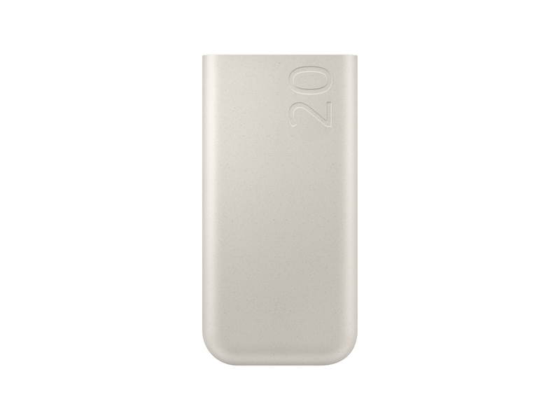

[Accessible Carousel](https://www.samsung.com/us/mobile/mobile-accessories/phones/45w-20-000-mah-battery-pack-beige-eb-p4520xuegus/)

[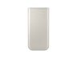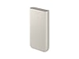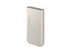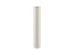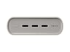](javascript:;)

**45W 20,000 mAh Battery Pack, Beige**

**EB-P4520 /EB-P4520XUEGUS**

3.4 out of 5 stars, average rating value. Read 5 Reviews. Same page link.

3.4

(5)

Write a review

Share your product experience

https://image-us.samsung.com/SamsungUS/New/truck.png?$default-png$

Get it by Dec. 23

**45W 20,000 mAh Battery Pack, Beige$43.99**

https://image-us.samsung.com/SamsungUS/home/store-locator/storepickup.png?$default-png$

**In-Store Pickup:Samsung 837**

Get it today

https://image-us.samsung.com/SamsungUS/home/vc2-0/truck-icon.png?$default-png$

**Delivery for:10001**

Get it by Dec. 23

Total

**$1.83**/mo for **24** mos at **0%** APR⊕

**$43.99**~~$54.99~~

You Saved Today**$11.00**



**Log in to earn up to 3 points per $1**

[**ADD TO CART**](javascript:;)

[**WHERE TO BUY**](https://www.samsung.com/us/mobile/mobile-accessories/phones/where-to-buy/45w-20-000-mah-battery-pack-beige-eb-p4520xuegus/EB-P4520XUEGUS)

Supported payment types:

Credit Cardhttps://image-us.samsung.com/SamsungUS/home/tv-pdp-conf/paypal-logo.png?$default-png$https://image-us.samsung.com/SamsungUS/home/tv-pdp-conf/amazon-pay.png?$default-png$https://image-us.samsung.com/SamsungUS/home/tv-pdp-conf/icn_google-pay-mark.png?$default-png$https://image-us.samsung.com/SamsungUS/home/tv-pdp-conf/samsung-financing.png?$default-png$

**Buying online has never been easier or safer**

**Free Shipping**

**Order with confidence. Safe, contact-free two-day delivery.**

[**LEARN MORE- Free Shipping**](https://www.samsung.com/us/support/order-faqs/#questionID20)

**Exclusive business savings**

**Enjoy exclusive volume discounts on eligible accessories, 0% Samsung Business Financing and limited time instant savings.**

[**LEARN MORE- Exclusive business savings**](https://www.samsung.com/us/business/shop/all-deals/watches-audio-accessories-deals/)

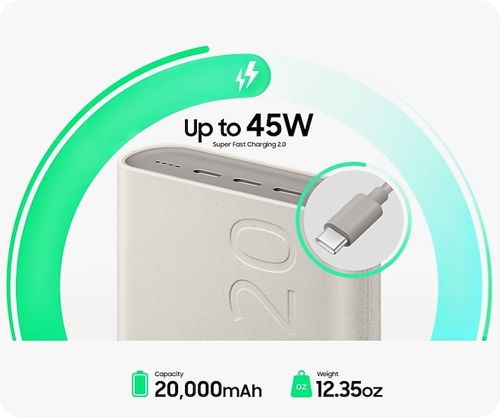

**On the go Super Fast Charging**

The 45W 20,000mAh Battery Pack with Super Fast Charging 2.0¹  allows you to charge your device in a flash. With a 5A USB C cable included, you have what you need to charge on the go.

*¹Super Fast Charging 2.0 only available when charging a single device capable of Super Fast Charging 2.0.*

**Charge three devices simultaneously**

The Triple Port allows you to charge three devices at the same time for added convenience and power when you need it the most. ¹,²

*¹Actual charging speed depends on battery level and other factors. Charging speeds vary depending on the number of devices; when charging three devices charging speed is up to 15W per port.  
²Includes one (1) 5A USB C cable (other products and cables sold separately); use only Samsung approved chargers and cables. To avoid injury or damage to your device, do not use incompatible, worn or damaged batteries, chargers or cables.*

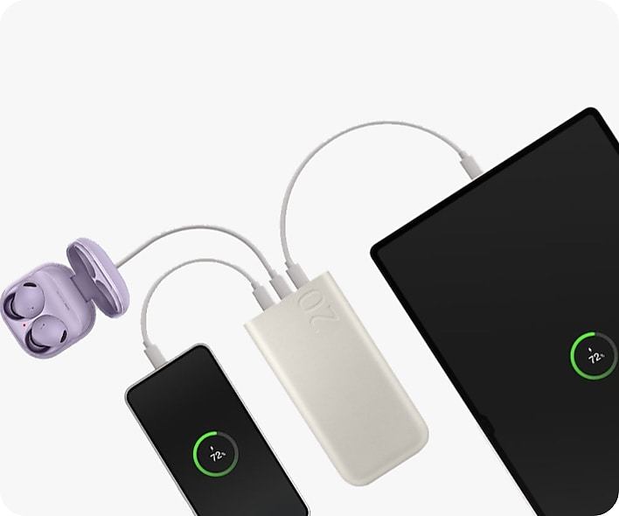

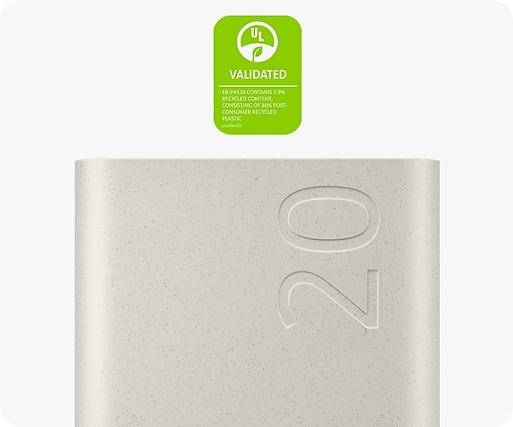

**Power with a purpose**

The 45W 20,000mAh Battery Pack is designed with the environment in mind. It contains UL certified recycled material.¹

*¹The 45W 20,000mAh Battery Pack contains a minimum of 5.9% recycled content (UL ECVP 2809 2), consisting of 30% post consumer recycled plastic. For more information on UL standards, see: https://www.ul.com/services/environmental claim validation ecv. 45W 20,000mAh Battery Pack*